URL = <http://sotd.us/austinvanraden/CIS4655C-WebDev/Module%203/Project/Mod3Project.html>

Github repo = <https://github.com/AustinVanStroodleBerry/CIS4655C-WebDev/tree/master/Module%203/Project>

Home page on desktop

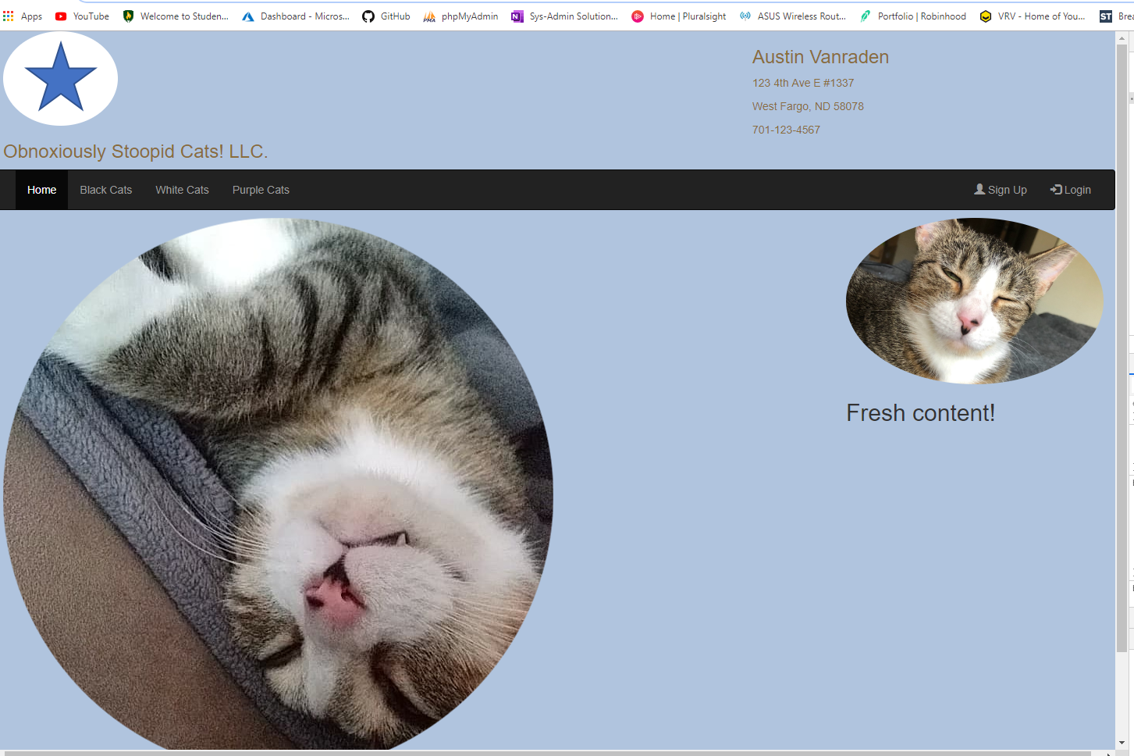

Different page from nav bar (activated page on nav bar signals new page)

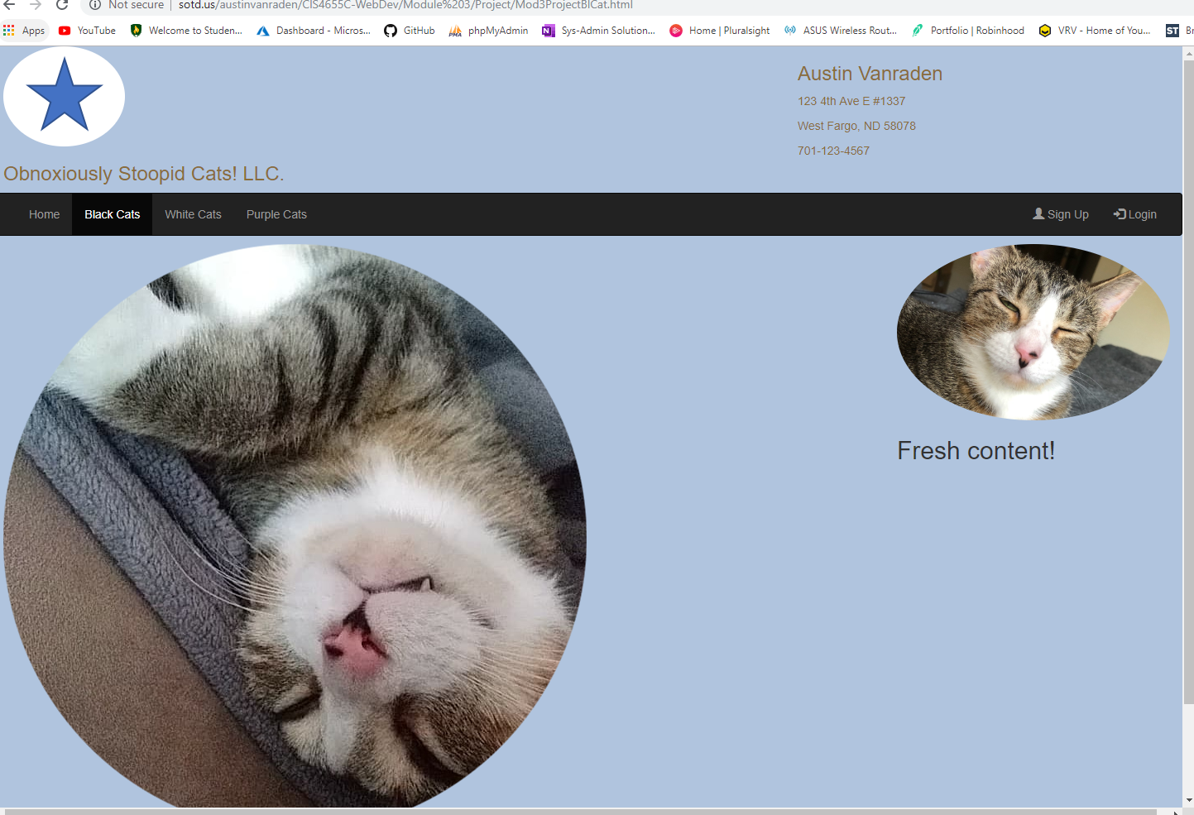

Galaxy S5 view (collapsed nav bar)

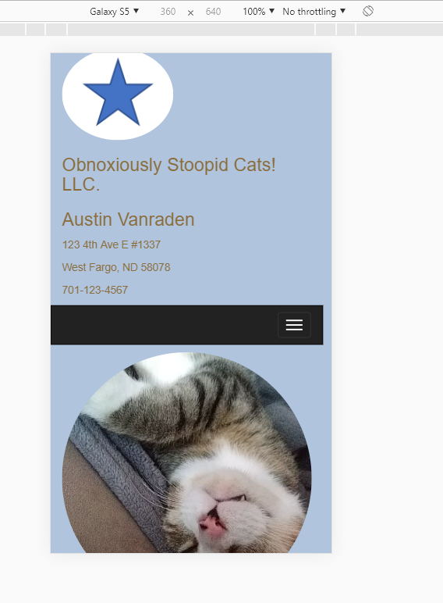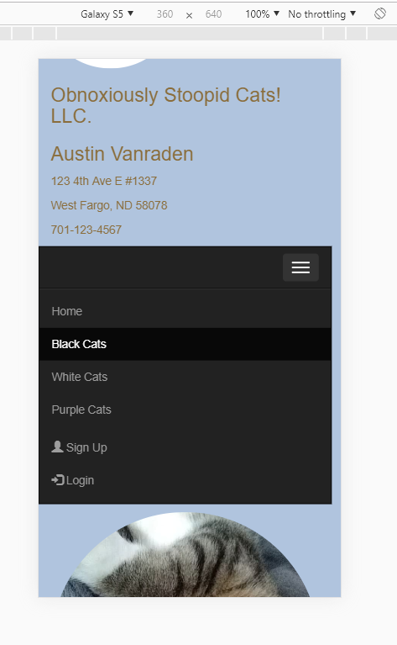

Ipad

